Title: Ecological Drivers of Seedling Establishment and Survival: a test of the stress-gradient hypothesis

**Authors:** Katherine D. Jones1 and Thomas N. Kaye1,2

1 Oregon State University, Department of Botany and Plant Pathology, 2082 Cordley Hall, Corvallis, Oregon 97331-2902

2 Institute for Applied Ecology, P.O. Box 2855, Corvallis, Oregon 97339

Corresponding Author: K Jones,

National Ecological Observatory Network (NEON), 1685 38th Street, Boulder, CO 80302

720-330-1550

kjones@neoninc.org

Running Title:

Word Count: Summary - #; Main text - #; Acknowledgements - #; References - #; Tables and Figures - #

Number of Tables: 2

Number of Figures: 9

Number of References:

Financial support provided by the Portland Garden Club and the Native Plant Society of Oregon Willamette Chapter.

**Summary**

The stress gradient hypothesis states that plant community interactions shift from competition in low stress environments to facilitation in high stress environments. We tested for competition and facilitation in a high stress environment in the Willamette Valley, Oregon, USA and hypothesized that positive interactions would be the primary driver of establishment at our sites but that interactions likely differ between plant functional groups and between life history stages. We direct seeded or planted five species of native perennial forbs of conservation concern, *Lupinus oreganus*, *Castilleja levisecta*, *Erigeron decumbens, Iris tenax* and *Sidalcea malviflora* ssp. *virgata,* into 20 experimentally manipulated plots with differing plant community structure at each of three sites. Seedling establishment and survival was tracked over two growing seasons. We used linear regression to test for effects of cover by various plant functional groups, litter, bare soil and disturbance on seedling success.

Synthesis and applications.There was evidence of indirect facilitation of *L. oreganus, S. malviflora* ssp. *virgata* and *C. levisecta* by grass in the form of leaf litter. Facilitation by litter is contrary to the common perception that litter inhibits plant establishment but supports the theory that facilitation is more common in high stress sites. For restoration of degraded habitats in high stress environment, this suggests a phased approach; land managers should consider seeding target forb species prior to eradicating invasive grasses or after successfully establishing native grasses.

Keywords: Restoration, facilitation, competition,

**Introduction**

Habitat loss and competition from non-native species are leading causes of declines in diversity (Morse 1996; Czech 1997; Wilcove *et al.* 1998). The list of threatened and endangered species is growing at an increasing rate (Pimm & Raven 2000); in some cases, whole ecosystems are at risk of being lost (Noss, LaRoe III & Scott 1995). Restoring this diversity is a major challenge facing ecologists and land managers (Dobson 1997; Hobbs & Harris 2001) and there is a clear call to answer these challenges through the direct application of ecological theory (Palmer, Ambrose & Poff 1997; Miller & Hobbs 2007).

In applied ecology, primary ecological concepts provide managers with a theoretical framework from which to develop restoration protocols based on the biology of individual species (Sarrazin & Barbault 1996; Palmer, Ambrose & Poff 1997; Zedler 2005). In plant community ecology, the stress-gradient hypothesis proposes that competitive interactions between plant species have greater importance in low or moderate stress environments and that as stress conditions increase, facilitative interactions become more prevalent (Bertness & Callaway 1994; Tielbörger & Kadmon 2000). Within a particular habitat type, effective restoration techniques will differ in locations with differing stress conditions (Padilla & Pugnaire 2006) and it is likely that interactions will differ among life history stages (Brown & Van Staden 1997; McPeek & Peckarsky 1998; Maestre, Valladares & Reynolds 2005). Even under a particular stress environment, interspecific plant interactions differ between functional groups as resource use varies among functional groups (Hooper 1997). In prairie systems, grasses, especially non-native invasive species, tend to be taller and faster growing than many native forbs (Blossey & Notzold 1995; Wilson 1998; Wilson & Clark 2001) and therefore frequently suppress native forbs regardless of the stress conditions. Disturbance, especially herbivory, can also have significant effects on plant community structure and may obscure effects of either competition or facilitation between plant species (Hambäck & Beckerman 2003; Brooker *et al.* 2006). Plant establishment can be affected by plant community composition through competition or facilitation, but disturbance may disrupt these processes. Successful conservation efforts, especially reintroduction of species with important ecosystem functions or species of particular conservation concern (Srivastava & Vellend 2005; Isbell *et al.* 2011) will be achieved through identifying and applying ecological theories that drive community structure and ecosystem dynamics at a particular location (Thorpe & Stanley 2011). Conservation of species *interactions* is essential to successful ecosystem restoration (Soulé *et al.* 2003); individual species reintroductions therefore, should be conducted within an ecosystem context.

The research presented here was designed to identify interactions, positive and negative, that drive establishment of native species of conservation concern in an endangered grassland ecosystem, upland prairies of the Willamette Valley, Oregon, USA. We focused on five native plant species that are threatened or endangered and provide essential ecosystem functions for two endangered butterflies, the Fender’s blue and Taylor’s checkerspot. We asked the question, ‘Which plant community interactions determine establishment and survival of these forbs?’.

Based on the stress-gradient hypothesis (Bertness & Callaway 1994; Callaway & Walker 1997) and the life history of these species, we tested several hypotheses:

H1: Plant community interactions in this region are dominated by facilitation at the seedling stage with existing plants protecting vulnerable seedlings. Competition is likely more prevalent at later life history stages as forbs mature and develop similar resource requirements to the established plant community.

H2: Plant community interactions differ between functional groups; grasses are more likely than established forbs to exert a competitive effect on establishment of planted forb species.

H3: Disturbance by herbivores and burrowing rodents will have a negative effect on establishment and will obscure plant-plant interactions if incidence is high.

We broadcast seeds and planted vegetative plugs into manipulated prairie communities to address these hypotheses.

**Methods**

*Study System*

Temperate latitudes have experienced some of the greatest losses of biodiversity due to intense development and exploitation by humans (Noss, LaRoe III & Scott 1995). Grasslands and savannas (prairies) in particular are among the most endangered ecosystems in the United States based on their decline, current extent, imminence of threat, and number of associated threatened and endangered species (Noss & Peters 1995; Noss 2000). The Willamette Valley is no exception; with significant loss of native ecosystems. Prior to European settlement, the Willamette Valley was a mosaic of coniferous forests, oak savannas and grassland prairies with high plant and animal diversity. Habitat loss, caused by conversion to agriculture, urbanization and natural succession to shrubland and forest due to loss of disturbance regime has reduced native habitats to a fraction of their pre-settlement extent (Alverson 2005). Before 1850, prairies likely covered 30% (409,000 hectares) of the valley floor (Altman *et al.* 2001). Upland prairies accounted for approximately 277,000 hectares, two-thirds of Willamette Valley prairies (U.S. Fish and Wildlife Service 2000). Today, less than 0.5% remains (Wilson *et al.* 2003). With 99.5% habitat loss, the upland prairie ecosystem of western Oregon is one of the most endangered ecosystems in the United States (Noss, LaRoe III & Scott 1995).

Our five study species are, Kincaid’s lupine (*Lupinus oreganus* A. Heller), Willamette daisy (*Erigeron decumbens* Nutt.), golden paintbrush (*Castilleja levisecta* Greenm.), roughleaf iris (*Iris tenax* Douglas ex Lindl.), and rose checkermallow (*Sidalcea malviflora* (DC.) A. Gray ex Benth. ssp. *virgata* (Howell) C.L. Hitchc.). *L. oreganus, E. decumbens* and *C. levisecta* are all threatened or endangered species in the Willamette Valley. *I. tenax* and *S. malviflora* ssp. *virgata* were also included because of high seed availability and their value as nectar resources for endangered butterflies (Schultz & Dlugosch 1999; Schultz 2001) (see Table 1 for details). Nomenclature follows the Oregon Flora Project (Cook and Sundberg (eds.) 2011).

Our study sites are located at the southern end of the Willamette Valley/Puget Trough/Georgia Basin (WPG) Ecoregion. This region spans almost 600 km from north to south. Soil moisture content, fertility and organic matter increase with latitude. The northern portions of the region therefore have more productive, low stress environments while the southern end is characterized as having less productive, higher stress environments (Richardson *et al.* 2012).

From 2005-2010, the Institute for Applied Ecology (IAE), in coordination with The Nature Conservancy (TNC) conducted a long-term manipulative experiment to identify effective techniques for controlling invasive perennial grass species and promoting native plant assemblages in grassland communities throughout the WPG Ecoregion. The IAE/TNC project employed a multi-site, multi-variable design to test the effectiveness of a variety of management treatments. Treatments included the application of a grass-specific herbicide, spring or fall mowing and burning plus application of a post-burn broad-spectrum herbicide on 5 x 5 m experimental units, treatments were followed by seeding native grasses and forbs (Stanley et al., 2008). The treatment units represent a range of community composition from high perennial forb cover with low litter abundance to high invasive grass and litter cover (Stanley, Kaye & Dunwiddie 2008, 2011; Stanley, Dunwiddie & Kaye 2011; Richardson *et al.* 2012).

We utilized three of the IAE/TNC study sites (Figure 1), two at William L. Finley National Wildlife Refuge, Pigeon Butte (44°23.9’ N, 123°19.2 W) and Bellfountain (44°24.2’ N, 123°20.9’ W ), and one at Fort Hoskins Historic Park (44°40.8’ N, 123°27.8’ W) administered by Benton County, Oregon. Elevation at study sites ranged from 112-138 m above mean sea level. Soils are all moderately deep to very deep and well-drained formed from colluvium and residuum derived from basalt, igneous bedrock or sedimentary rocks. All sites have a Mediterranean climate, characterized by mild wet winters and dry summers with an average annual precipitation of 171 cm. The two years we made observations, 2010 and 2011, experienced spring temperatures that were cooler than average with above average precipitation in this region.

*Experimental Design*

To test for effects of associated vegetation on plant establishment, we seeded or planted plugs of our target species into the 20 manipulated communities at the three Oregon sites. We established 0.5 x 2 meter plots oriented within the IAE/TNC project plots in a quadrant of the plot seeded in 2007. We broadcast seeds of *L. oreganus, S. virgata, I. tenax* and *E.decumbens* into each plot in November of 2009. The number of seeds sown varied by species. Estimates of seed viability from tetrazolium chloride (TZ) tests were available for *S. virgata* and *I. tenax*, so seed numbers were adjusted to sow approximately 100 viable seeds. Specifically, viability of *S. malviflora* ssp. *virgata* seed was estimated at 84% (commercially reported live seed) and seed number was increased to 119 seeds per plot to achieve an average sowing rate of 100 viable seeds. Seeds of *I. tenax* came from two commercial sources (Silver Falls Seed Company and Heritage Seedlings) with viabilities of 69% and 77%, and corresponding seeding rates of 129 and 145 seeds to sow an estimated 100 viable seeds per plot. Previous studies show that *E. decumbens* has low establishment (<1%, Kaye and Brandt 2005) and typically low viability (0-39%, Clark et al. 1997, Thorpe and Kaye 2011). Although viability estimates were not available for this seed lot, we compensated for the poor expected establishment rates by sowing 1000 seeds in each plot, estimated by weight; seven sets of 1000 seeds were hand counted and weighed to estimate the average weight, which was then used to measure the remaining seeds.

One hundred *L. oreganus* seeds were broadcast over half of the 2 m x 0.5m plots. In addition, 50 *L. oreganus* seeds were broadcast in one 0.5 x 0.5 m plot in each treatment unit in November 2006. We planted five plugs each of *C. levisecta* and *I. tenax* inJune and November of 2010, respectively. Plugs of *C. levisecta* were planted at Bellfountain only due to limited availability of this species, while *I. tenax* was planted at all three sites. In both cases, plugs were planted on 50 cm spacing along one edge of the 0.5 x 2 m plots, with *I. tenax* and *C. levisecta* on opposite sides at Bellfountain. Though the range of current conditions in these plots is the result of previous treatments (Richardson *et al.* 2012), we characterized the community composition of each plot individually rather than grouping by treatment history. Given this study design, we cannot separate effects of community components from treatment history.

*Data Collection*

*Cover estimates*

We conducted ocular estimates of cover to the nearest 1% of grasses, forbs, moss, litter, bare soil and disturbance. Estimates were made for each 0.5 x 0.5 m in the plot. Litter depth was measured at five points in each 1 x 0.5 m plot. Estimates were made for each growing season. In 2011 we centered a 0.5 x 0.5 m plot over lupine planted in 2006 and estimated percent cover of grasses, forbs, moss, litter, bare soil, and disturbance.

*Establishment by seed*

Throughout this paper, we refer to the proportion of seeds that *establish* rather than *germinate*; and we define establishment as the proportion of seeds that germinated, emerged and produced photosynthetic cotyledons and/or true leaves that were present at the time we visited each plot in 2010 (definition adapted from Harper 1977). This count excludes seeds that may have emerged and died before our survey of the plots as well as seeds that never germinated.

For two consecutive years, 2010 and 2011, we conducted demographic surveys of all experimental plots in April and May of 2010 then again in May 2011. We mapped the location of each individual that established from seed by measuring coordinates to the nearest centimeter within a 1 m x 0.5 m plot frame and mapping them on a paper datasheet to scale. Using the map we developed, we relocated individuals the following year. For each individual we counted number of leaves at each survey to get a relative estimate of growth.

In 2011, we measured *L. oreganus* seeds sown in 2006 by counting the number of lupine leaves present. After 5 years of growth, many individuals had grown together and single individuals may have had multiple stems coming from the ground therefore it was often difficult to distinguish one individual from another. We used the number of *L. oreganus* leaves as a measure of overall success of the 50 seeds sown in 2006.

*Transplants*

For *I. tenax,* we noted if the individual survived, counted the number of leaves and measured the length of the longest leaf blade. *C. levisecta* produces multiple shoots from the ground, we measured the length of each shoot an individual produced and noted whether or not they produced flowers.

*Statistical Analysis*

Data were analyzed using R statistical software, version 2.14 (2011). Our response variables are the proportion of seeds that establish and proportion of established seeds or vegetative transplants that survive in our experimental plots. Our explanatory variables are percent cover of existing vegetation, grouped by functional group and average litter depth, measured in centimeters.

Cover estimates were averaged across the 0.5 x 1 m split-plot for *L .oreganus* and across the whole 0.5 x 2 m plot for all other species. We used Analysis of Variance and simple descriptive statistics on the community components to verify that our manipulated communities represented a wide range of community conditions.

We used Analysis of Variance (ANOVA) to test for differences among the three sites and, although establishment did not always significantly differ by site, site was a blocking factor and therefore was accounted for in all Multiple Regression models. We used Simple Linear Regression to test for community interactions with planted *C. levisecta* plugs, and we used Multiple Linear Regression to test for the effect of surrounding vegetation on initial establishment and survival of seeds planted in 2009 and *I. tenax* plugs planted in 2010.

Although we determined that there was no density dependence for this species, in 2011 survival was analyzed for each split plot to retain the 0.5 m resolution of cover estimates for all of the seeds with a shared treatment history.

Our threshold for statistical significance was p=0.05 but because our primary interest is identifying any *potential* interactions between our study species and the existing plant community, we report results to p=0.1 as being suggestive or equivocal and worthy of note.

**Results**

*Community Components*

Grass cover in our plots ranged from 0 to 80% and differed by site (f=5.77, df=2, p=0.03, ANOVA F-test). Cover by forbs ranged from 19% to 93% and did not differ significantly by site (f=5.77, df=2, p=0.34). Total cover of vascular plants, the sum of grass and forb estimates, ranged from 42 to 121% and did not differ by site (f=0.32, df=2, p=0.72). Litter depth ranged from 0.25 to 5.10 centimeters and was closely correlated with grass cover (p<0.0001; Figure 2). Disturbed area of plots caused primarily by moles ranged from 0 to 50% and differed by site (f=11.35, df=2, p=0.0001).

*Lupine*

*Establishment*

L. oreganus establishment did not differ among sites (p=0.78). After accounting for site, there is convincing evidence that litter depth was positively correlated with establishment after accounting for site (p=0.03, R2=0.11, see Table 2 for all regression models). The correlation with litter depth was demonstrated at Pigeon Butte (p=0.06) and Ft. Hoskins (p=0.069) but not at Bellfountain (p=0.29, Figure 3).

*Seedling survival*

Survival in 2011 of plants that established in 2010 differed by site (f=14.97, df=2, p<0.0001). Survival however did not depend on scarification (f=2.25, df=1, p=0.33), nor on the number of plants that established in 2010 (f=0.29, df=1, p=0.48 ANOVA F-test).

Survival was positively correlated with litter depth after accounting for site (p=0.05, R2=0.30; Figure 4). Disturbance by moles was strongly negatively correlated with survival after accounting for site (p=0.0005, R2=0.39, Figure 4).

Only half of the plots at Bellfountain and Ft. Hoskins that were planted with *L. oreganus* in 2006 still had lupine present in 2011. Plots without lupine present had about 26% higher grass cover than plots with lupine (p=0.001, 95%CI 11%-41%). Plots with flowering lupine had a higher mean number of leaves (f=23.4, df=1, p=0.0001 ANOVA F-test; Figure 5). Of the plots with lupine, median leaf number was positively correlated with litter depth (p=0.07) after accounting for site. All other community factors appeared to have a neutral effect on median leaf number (Table 3).

*Sidalcea*

*Establishment*

Initial establishment of *S. malviflora* ssp. *virgata* differed by site (f=7.49, df=2, p=0.002 ANOVA F-test). After accounting for site, none of the community components we measured were correlated with initial establishment in our multiple regression models.

*Seedling survival*

Survival of seedlings that established in 2010 did not differ by site (f=1.59, df=2, p=0.21 ANOVA F-test). After accounting for site, litter depth was positively correlated (p=0.004) with seedling survival (Figure 6) and there was equivocal evidence that bare ground (p=0.07) and convincing evidence that incidence of disturbance by moles (p=0.007), were negatively correlated with survival.

*Castilleja*

Establishment of *C. levisecta* plugs planted in 2010 was not correlated with cover of any of the functional groups we measured, but survival to 2011 was positively correlated with grass (p=0.07), total cover of grasses and forbs (p=0.04), and litter depth (p=0.01; Figure 7). Persistence to 2011 was negatively correlated with bare ground (p=0.008) and disturbance by moles (p=0.03).

*Iris*

In 2010, we were unable find any *I. tenax* seedlings at any site and therefore could not compare seedling establishment to community characteristics. Our 2011 survey found a total of 29 individuals in only 5 plots that established from seed, most of them at Ft. Hoskins but this was insufficient for statistical analysis.

*Survival of transplants*

There was an average of 76% survival of transplanted *Iris*. Survival did differ by site (f=4.26, df=2, p=0.019, ANOVA F-test), this effect was driven by the nearly 100% survival at Pigeon Butte (Figure 8). Due to the generally high survival rate overall, we were unable to detect a significant positive or negative affect from any of community component we measured.

*Erigeron*

We only found a handful of *Erigeron* seedlings in either 2010 or 201l, our sample size was insufficient for statistical analysis. Only nine individuals in two plots were found at Ft. Hoskins, four individuals established in two plots at Pigeon Butte. None of the individuals found in 2010 were relocated in 2011.

**Discussion**

*Facilitation and Competition*

Though we did not test a range of stress conditions, our results are consistent with the stress-gradient hypothesis that suggests that stressful environments tend toward facilitative interactions (Bertness & Callaway 1994; Callaway & Walker 1997; Richardson *et al.* 2012). Plant interactions in our stressful habitat do tend toward facilitation. Because litter in these prairies is primarily the result of grass, the effects of litter on establishment are an indirect effect of grass. The indirect effect of grass through litter accumulation was the strongest potential driver of seedling establishment of *Lupinus oreganus* and seedling survival of *Sidalcea malviflora* ssp. *virgata* at our sites. Litter accumulation, resulting from abundant native and non-native grasses, was positively correlated with establishment of non-scarified seeds of *L. oreganus*, and *S .malviflora*. Litter depth was also correlated with survival in the second year for *L. oreganus, S. malviflora* ssp. *virgata*, and *Castilleja levisecta*. We saw potentially positive interactions with grass (as a direct effect), moss and total vegetative cover (Table 2) for *C. levisecta* at Bellfountain and *L. oreganus* and *S. malviflora* ssp. *virgata* at individual sites. Most of our planted species performed better with more neighbors. Clark and Wilson (2003) also found that seedling mortality was high in gaps between established plants and attributed this effect to the variable abiotic conditions common to this region.

Litter is generally considered to have an inhibitory effect on seed germination and establishment though this trend is weaker in grasslands than in forest or forb dominated environments (Ryser 1993; Xiong & Nilsson 1999). Both the physical and chemical environments are affected by the presence of plant litter (Facelli & Pickett 1991). Litter can intercept light, regulate temperature and help conserve soil moisture (Amatangelo, Dukes & Field 2008).

In Willamette Valley prairies, litter has been shown to have both positive and negative effects on seed establishment (Clark & Wilson 2000). For example, Maret and Wilson (2005) found that litter suppressed establishment of broadcast seeds, in Western Oregon grasslands. Their study species all had relatively small seeds compared to *L. oreganus* and *S. malviflora* ssp. *virgata*. Perhaps the negative effects in this case were the result of litter preventing soil-to-seed contact. Jensen and Guteknust (2003) found that in the presence of litter, seedling establishment was positively correlated with seed size. Our larger smooth un-barbed and un-appendaged seeds may have been more successful at passing through the litter layer to achieve soil contact. In another study, Wilson and Clark (2001) recommend mowing tall invasive grasses without removal of cut material to promote native species already represented in the community which supports our findings that litter was also associated with increased survival of established individual.

*Differences in interaction by functional group*

We found no indication that grass inhibited establishment in the first two years of any of the species we seeded in our plots. In fact we found the opposite; litter depth, an indirect effect of grass was positively correlated with increased establishment and survival of *L. oreganus*, survival of *S. malviflora* ssp. *virgata* and second year survival of *C. levisecta.*

All of the negative effects we measured for establishment and survival of seedlings in their first two years were correlated with the abiotic factors, disturbance and bare ground. This indicates that the *lack* of neighbors to interact with or burial and removal by burrowing rodents may be negatively affecting the ability to establish and persist. Direct interactions with biotic community components, grass, forbs and moss appear to be primarily neutral in the early stages of establishment but may tend towards competition at later life history stages.

*Competition and Facilitation at different life history stages*

In our study, the number of leaves was a reasonable proxy foroverall performance of *L. oreganus* as it was correlated with flowering and thereby reproductive potential. With respect to leaf number, we saw a potential shift from neutrality to competition with grass cover in five-year old lupine compared to seedlings, but litter depth still was positively correlated with overall performance. Wolkovich et al (2009) demonstrated how litter alters the biotic and abiotic environment and enhances growth of adult *Artemisia californica,* though non-native grasses likely interacted competitively with young *A. californica*. We may see something similar where litter in our study system is interacting positively with our species at both the seedling and adult stages but that the net balance of facilitative or competitive interaction shifts at an intermediate life history stage (Figure 9A).

We did not have mature individuals for any of the other species we tested in which to compare this trend but we expect that transitions from facilitation or neutrality to a competitive relationships (Figure 9B), especially with grass, may occur for other species as well. Though facilitation is occurring, the shift from facilitative to competitive interactions over the life on an individual may correspond with an overall negative effect on the population over time (Williams & Crone 2006).

*Iris and Erigeron*

Once established, *Iris tenax* had a high survival rate such that it was not possible to correlate iris success with any community component. Like many irises, *I. tenax* is a clonal species (Wilson 2001) and the seeds appear to have dormancy (Jones & Kaye 2014). For restoration purposes, seed may not be the most efficient way to establish *Iris* (Volis, Blecher & Sapir 2007).

Previous studies have shown that establishment of *Erigeron decumbens* seed viability is often very low, especially among seeds from small populations (Thorpe & Kaye 2011) and establishmentby seed is also very low, sometimes <1% (Kaye & Brandt 2005). Even so, actual establishment rates in our study sites may have been higher than we observed; seedlings and juvenile *E. decumbens* are very small and may easily be confused with young grasses or young *Plantago lanceolata*, both of which were abundant in our plots. However, our results are consistent with what others have found; this does not seem to be a species that is well suited to direct seeding. Transplants are the best option for reintroduction of this species (Thorpe 2009).

*Biological relevance*

Although our results are suggestive statistically of positive or negative interactions with community components, some of the effects we observed were weak. In our regression analysis, our strongest positive signals came from the indirect interaction of target species with grass in the form of litter depth. Other community factors such as cover by grasses, forbs and total cover had minor slopes (see for example Figure 8C). Though these slopes appear to be nearly flat in some cases, they still provide evidence that suggests a facilitative interaction between these community factors and the target species. The winters of 2010 and 2011 were mild; they were wetter and cooler than the average for the Willamette Valley. If, as Callaway (1997) posits, facilitative effects increase as abiotic stress increases, we’d expect the positive interactions we observed to be even stronger in warmer, drier years.

*Implications for Management*

Unfortunately, there is no panacea or universal prescription for ecosystem restoration. Effective restoration strategies must be goal driven (Zedler 2005), therefore strategies must differ depending on the scale (species or community level) at which managers are working. In the case of target species augmentation or reintroduction, the management strategy needs to be tailored to the individual species. In stressful sites, for medium to large-seeded perennial forbs that we tested, *Lupinus* and *Sidalcea* seeding should occur prior to removal of undesirable grass species or after successful establishment of native grasses. Since litter from grasses appears to enhance establishment of these species, we recommend leaving existing litter in place until a couple years after seeding. Mowing to control tall invasive grasses may be implemented if cut material is left on the ground. Targeted removal of invasive grasses should wait until target restoration species are established unless litter addition is included in the management activities. Though removal of invasive grasses may be postponed, it appears that it is a necessary step at some point to establish sustainable populations.

Seeding may not be the ideal method for introducing *Iris tenax*; managers should consider greenhouse propagation and transplanting of this species.

Disturbance by moles which dig up, eat, or bury seedlings was the strongest single factor that limited establishment of *Lupinus* and *Sidalcea*. We recommend managers survey restoration sites for burrowing rodents prior to reintroduction. If rodent populations are high, it would be wise to take steps to mitigate the detrimental effects of herbivory and soil disruption that these mammals have on establishing seedlings; rodent exclosures, removal of rodents, increased seeding rates, or preferentially selecting sites with lower abundance of moles may increase the chances of success.

Plant reintroduction will be more successful by taking the time to characterize the stress environment of restoration sites and developing reintroduction strategies that work with the unique conditions of the site and the individual requirements of the species to capitalize on interactions between plant functional groups.

**Acknowledgements**

**Data Accessibility**

**References**

Altman, B., Hayes, M., Janes, S. & Forbes, R. (2001) Wildlife of westside grassland and chaparral habitats. Pages 261-291. *D.H. Johnson and T.A. O’Neil, Managing Directors. Wildlife-habitat Relationships in Oregon and Washington* p. 736. Oregon State University Press, Corvallis, OR.

Alverson, E. (2005) Preserving prairies and savannas in a sea of forest: A conservation challenge in the Pacific Northwest. *Plant Talk*, **40**, 23–27.

Amatangelo, K.L., Dukes, J.S. & Field, C.B. (2008) Responses of a California annual grassland to litter manipulation. *Journal of Vegetation Science*, **19**, 605–612.

Bertness, M.D. & Callaway, R. (1994) Positive interactions in communities. *Trends in Ecology & Evolution*, **9**, 191–193.

Blossey, B. & Notzold, R. (1995) Evolution of increased competitive ability in invasive nonindigenous plants: a hypothesis. *Journal of Ecology*, **83**, 887–889.

Brooker, R.W., Scott, D., Palmer, S.C.F. & Swaine, E. (2006) Transient facilitative effects of heather on Scots pine along a grazing disturbance gradient in Scottish moorland. *Journal of Ecology*, **94**, 637–645.

Brown, N. & Van Staden, J. (1997) Smoke as a germination cue: a review. *Plant Growth Regulation*, **22**, 115–124.

Callaway, R.M. (1997) Positive interactions in plant communities and the individualistic-continuum concept. *Oecologia*, **112**, 143–149.

Callaway, R.M. & Walker, L.R. (1997) Competition and facilitation: a synthetic approach to interactions in plant communities. *Ecology*, **78**, 1958–1965.

Clark, D.L., Ingersoll, C.A. & Finley, K.K. (1997) Regeneration of Erigeron decumbens var. decumbens (Asteraceae), the Willamette daisy. *Kaye, T.N; Liston, A.; Love, R.N.; Luoma, D.L.; Meinke, R.J.; Wilson, M.V., editors. Conservation and Management of Native Plants and Fungi* pp. 41–47. Native Plant Society, Corvallis, Oregon.

Clark, D. & Wilson, M. (2000) Promoting regeneration of native species in Willamette Valley upland prairies. *Report to USDI Fish and Wildlife Service and Oregon Natural Heritage Program. Corvallis (OR): Oregon State University*.

Clark, D.L. & Wilson, M.V. (2003) Post-dispersal seed fates of four prairie species. *American journal of botany*, **90**, 730–735.

Cook, T. & Sundberg (eds.), S. (2011) Oregon Vascular Plant Checklist.

Czech, B. (1997) Distribution and Causation of Species Endangerment in the United States. *Science*, **277**, 1116–1117.

Dobson, A.P. (1997) Hopes for the Future: Restoration Ecology and Conservation Biology. *Science*, **277**, 515–522.

Facelli, J.M. & Pickett, S.T. (1991) Plant Litter: Its Dynamics and Effects on Plant Community Structure. *The Botanical Review*, **57**, 1–32.

Hambäck, P.A. & Beckerman, A.P. (2003) Herbivory and plant resource competition: a review of two interacting interactions. *Oikos*, **101**, 26–37.

Harper, J.L. (1977) *Population Biology of Plants*. Academic Press, New York, NY.

Hobbs, R.J. & Harris, J.A. (2001) Restoration ecology: repairing the earth’s ecosystems in the new millennium. *Restoration ecology*, **9**, 239–246.

Hooper, D.U. (1997) The Effects of Plant Composition and Diversity on Ecosystem Processes. *Science*, **277**, 1302–1305.

Isbell, F., Calcagno, V., Hector, A., Connolly, J., Harpole, W.S., Reich, P.B., Scherer-Lorenzen, M., Schmid, B., Tilman, D., van Ruijven, J. & others. (2011) High plant diversity is needed to maintain ecosystem services. *Nature*, **477**, 199–202.

Jensen, K. & Gutekunst, K. (2003) Effects of litter on establishment of grassland plant species: the role of seed size and successional status. *Basic and Applied Ecology*, **4**, 579–587.

Jones, K.D. & Kaye, T.N. (2014) Factors Influencing Germination of a Functionally Important Grassland Plant, Iris tenax. *PloS one*, **9**, e90084.

Kaye, T.N. & Brandt, A. (2005) Seeding and transplanting rare Willamette Valley prairie plants for population restoration. *Unpublished technical report prepared for the Eugene District, USDI Bureau of Land Management*.

Maestre, F.T., Valladares, F. & Reynolds, J.F. (2005) Is the change of plant-plant interactions with abiotic stress predictable? A meta-analysis of field results in arid environments. *Journal of Ecology*, **93**, 748–757.

Maret, M.P. & Wilson, M.V. (2005) Fire and litter effects on seedling establishment in western Oregon upland prairies. *Restoration Ecology*, **13**, 562–568.

McPeek, M.A. & Peckarsky, B.L. (1998) Life histories and the strengths of species interactions: combining mortality, growth, and fecundity effects. *Ecology*, **79**, 867–879.

Miller, J.R. & Hobbs, R.J. (2007) Habitat Restoration—Do We Know What We’re Doing? *Restoration Ecology*, **15**, 382–390.

Morse, L.E. (1996) Plant Rarity and Endangerment in North America. *Restoring Diversity: Strategies for Reintroduction of Endangered Plants. Edited by DA Falk, CI Millar and M Olwell* pp. 7–22. Island Press, Washington, D.C. and Covelo, California.

Noss, R.F. (2000) High-risk ecosystems as foci for considering biodiversity and ecological integrity in ecological risk assessments. *Environmental Science & Policy*, **3**, 321–332.

Noss, R.F., LaRoe III, E.T. & Scott, J.M. (1995) *Endangered Ecosystems of the United States: A Preliminary Assessment of Loss and Degradation*. Biological Report, National Biological Service, Washington, D.C.

Noss, R.F. & Peters, R.L. (1995) *Endangered Ecosystems of the Unites States: A Status Report and Plan for Action.* Defenders of Wildlife, Washington, DC.

Padilla, F.M. & Pugnaire, F.I. (2006) The role of nurse plants in the restoration of degraded environments. *Frontiers in Ecology and the Environment*, **4**, 196–202.

Palmer, M.A., Ambrose, R.F. & Poff, N.L.R. (1997) Ecological theory and community restoration ecology. *Restoration ecology*, **5**, 291–300.

Pimm, S.L. & Raven, P. (2000) Biodiversity: extinction by numbers. *Nature*, **403**, 843–845.

R Development Core Team. (2011) *R: A Language and Environment for Statistical Computing.* R Foundation for Statistical Computing., Vienna, Austria.

Richardson, P.J., MacDougall, A.S., Stanley, A.G., Kaye, T.N. & Dunwiddie, P.W. (2012) Inversion of plant dominance-diversity relationships along a latitudinal stress gradient. *Ecology*, **93**, 1431–1438.

Ryser, P. (1993) Influences of neighbouring plants on seedling establishment in limestone grassland. *Journal of Vegetation Science*, **4**, 195–202.

Sarrazin, F. & Barbault, R. (1996) Reintroduction: challenges and lessons for basic ecology. *Trends in Ecology & Evolution*, **11**, 474–478.

Schultz, C.B. (2001) Restoring resources for an endangered butterfly. *Journal of Applied Ecology*, **38**, 1007–1019.

Schultz, C.B. & Dlugosch, K.M. (1999) Nectar and hostplant scarcity limit populations of an endangered Oregon butterfly. *Oecologia*, **119**, 231–238.

Soulé, M.E., Estes, J.A., Berger, J. & Del Rio, C.M. (2003) Ecological effectiveness: conservation goals for interactive species. *Conservation Biology*, **17**, 1238–1250.

Srivastava, D.S. & Vellend, M. (2005) BIODIVERSITY-ECOSYSTEM FUNCTION RESEARCH: Is It Relevant to Conservation? *Annual Review of Ecology, Evolution, and Systematics*, **36**, 267–294.

Thorpe, A.S. (2009) The good, the bad, and the ugly: Challenges in plant conservation in Oregon. *Native Plants Journal*, **9**, 351–357.

Thorpe, A.S. & Kaye, T.N. (2011) Conservation and reintroduction of the endangered Willamette daisy: effects of population size on seed viability and the influence of local adaptation. *Native Plants Journal*, **12**, 289–298.

Thorpe, A.S. & Stanley, A.G. (2011) Determining appropriate goals for restoration of imperiled communities and species. *Journal of Applied Ecology*, **48**, 275–279.

Tielbörger, K. & Kadmon, R. (2000) Temporal environmental variation tips the balance between facilitation and interference in desert plants. *Ecology*, **81**, 1544–1553.

U.S. Fish and Wildlife Service. (2000) *Endangered and Threatened Wildlife and Plants; Endangered Status for ‘Erigeron Decumbens’ Var. ‘Decumbens’ (Willamette Daisy) and Fender’s Blue Butterfly (‘Icaricia Icarioides Fenderi’) and Threatened Status for ‘Lupinus Sulphureus’ Ssp. ‘Kincaidii’ (Kincaid’s Lupine)*.

Volis, S., Blecher, M. & Sapir, Y. (2007) *Iris Atrofusca of the Northern Negev: Population Differences and Creation in Situ Gene Banks. Report to the Israel Nature and Parks Authority*. Ben-Gurion University of the Negev.

Wilcove, D.S., Rothstein, D., Dubow, J., Phillips, A. & Losos, E. (1998) Quantifying threats to imperiled species in the United States. *BioScience*, **48**, 607–615.

Williams, J.L. & Crone, E.E. (2006) The impact of invasive grasses on the population growth of Anemone patens, a long-lived native forb. *Ecology*, **87**, 3200–3208.

Wilson, M.V. (1998) Upland prairie. *Chapter In: Part I US Fish and Wildlife Service Willamette Basin Recovery Plan. Portland (OR): US Fish and Wildlife Service Oregon State Office*

Wilson, C.A. (2001) Floral stages, ovule development, and ovule and fruit success in Iris tenax, focusion on var. gormanii, a taxon with low seed set. *American Journal of Botany*, **88**, 2221–2231.

Wilson, M.V. & Clark, D.L. (2001) Controlling invasive Arrhenatherum elatius and promoting native prairie grasses through mowing. *Applied Vegetation Science*, **4**, 129–138.

Wolkovich, E.M., Bolger, D.T. & Cottingham, K.L. (2009) Invasive grass litter facilitates native shrubs through abiotic effects. *Journal of Vegetation Science*, **20**, 1121–1132.

Xiong, S. & Nilsson, C. (1999) The effects of plant litter on vegetation: a meta-analysis. *Journal of Ecology*, **87**, 984–994.

Zedler, J. (2005) Ecological restoration: guidance from theory. *San Francisco Estuary and Watershed Science*, **3**.

**Tables**

|  |  |  |  |  |  |  |  |
| --- | --- | --- | --- | --- | --- | --- | --- |
| **Species Name** | **Common Name** | **Family** | **Conservation Status** | **Geographic Range** | **Butterfly resource** | **Plant Material Used** | **# Planted** |
| *Lupinus oreganus* | Kincaid’s Lupine | Fabaceae | Threatened | Western WA and OR | Host for FBB | Seed | 100/split plot |
| *Erigeron decumbens* | Willamette Daisy | Asteraceae | Endangered | Western OR | None known | Seed | ~1000 |
| *Castilleja levisecta* | Golden Paintbrush | Orobanchaceae | Endangered | Western WA and BC | Potential host for TCB | Vegetative Plugs | 5 at Bellfountain only |
| *Sidalcea malviflora* ssp. *virgata* | Rose Checkermallow | Malvaceae | Common | Western WA and OR | Nectar | Seed | ~100 |
| *Iris tenax* | Oregon Iris | Iridaceae | Common | OR, WA, CA | Nectar | Seed and Vegetative Plugs | ~100 seeds & 5 plugs |

Table 1 Plant species used in experimental seeding and planting

Table 2. Summary of all regression models with site as a blocking factor. Bold values are significant at p ≤ 0.1.

|  |  |  |  |  |  |  |  |  |  |  |
| --- | --- | --- | --- | --- | --- | --- | --- | --- | --- | --- |
|  |  | **Factor** | **Establishment** | | | | **Survival** | | | |
|  |  | **Slope** | **Intercept** | **R2** | ***p*** | **Slope** | **Intercept** | **R2** | ***p*** |
| ***Lupinus oreganus*** | Scarified Seeds | Grass | -0.007 | 12.1 | 0.009 | 0.92 | -0.15 | 38.9 | 0.23 | 0.3 |
| Forb | 0.09 | 7.13 | 0.03 | 0.67 | 0.1 | 28.4 | 0.22 | 0.5 |
| Moss | 0.013 | 11.68 | 0.009 | 0.92 | 0.09 | 30.5 | 0.22 | 0.6 |
| Bare | -0.278 | 12.09 | 0.03 | 0.59 | 0.26 | 31.6 | 0.21 | 0.8 |
| Disturbed | -0.165 | 12.1 | 0.3 | 0.75 | -0.25 | 34.6 | 0.22 | 0.5 |
| Litter Depth | 1.688 | 8.84 | 0.03 | 0.61 | -0.25 | 32.9 | 0.21 | 0.9 |
| Total Veg | 0.156 | -1.83 | 0.05 | 0.37 | -0.11 | 41.1 | 0.22 | 0.6 |
| Non-Scarified Seeds | Grass | 0.088 | 25.5 | 0.04 | 0.33 | 0.1 | 32.6 | 0.25 | 0.55 |
| Forb | -0.045 | 30.8 | -0.04 | 0.66 | 0.07 | 29.6 | 0.26 | 0.27 |
| Moss | -0.142 | 29.99 | 0.04 | 0.33 | 0.1 | 31.8 | 0.26 | 0.39 |
| Bare | -0.021 | 28.38 | 0.03 | 0.66 | -1 | 36.1 | 0.27 | 0.16 |
| Disturbed | -0.251 | 29.17 | 0.05 | 0.28 | **-0.7** | **40.3** | **0.39** | **0.0005** |
| Litter Depth | **3.394** | **21.36** | **0.1123** | **0.03** | **3** | **24.6** | **0.3** | **0.05** |
| Total Veg | 0.154 | 14.81 | 0.05 | 0.4 | **0.29** | **10.7** | **0.3** | **0.029** |
| ***Sidalcea malviflora*** | Seeds | Grass | -0.01 | 15.60 | 0.21 | 0.78 | 0.18 | 29.6 | 0.09 | 0.12 |
| Forb | -0.01 | 15.71 | 0.2 | 0.85 | -0.08 | 40.5 | 0.06 | 0.52 |
| Moss | 0.07 | 14.39 | 0.21 | 0.3 | 0.19 | 33.9 | 0.08 | 0.2 |
| Bare | 0.15 | 15.03 | 0.21 | 0.47 | **-1.54** | **40.3** | **0.1** | **0.07** |
| Disturbed | -0.15 | 15.74 | 0.22 | 0.2 | **-0.78** | **45** | **0.17** | **0.007** |
| Litter Depth | -0.3 | 15.71 | 0.2 | 0.76 | **5** | **20.2** | **0.19** | **0.004** |
| Total Veg | -0.07 | 21.66 | 0.2 | 0.4 | 0.2 | 18.14 | 0.08 | 0.17 |
| ***Iris tenax*** | Transplants | Grass |  | | | | -0.13 | 80.8 | 0.14 | 0.45 |
| Forb | 0.19 | 68.1 | 0.15 | 0.33 |
| Moss | -0.3 | 81.3 | 0.17 | 0.13 |
| Bare | 0.9 | 73.3 | 0.14 | 0.48 |
| Disturbed | 0.2 | 73.1 | 0.13 | 0.66 |
| Litter Depth | -2.5 | 83.5 | 0.14 | 0.35 |
| Total Veg | 0.07 | 69.1 | 0.13 | 0.8 |
| ***Castilleja levisecta*** | Transplants | Grass | -0.16 | 98.6 | 0.13 | 0.12 | **0.37** | **65** | **0.17** | **0.07** |
| Forb | 0.16 | 84.6 | 0.09 | 0.21 | -0.3 | 92.5 | 0.07 | 0.25 |
| Moss | 0.13 | 91.4 | 0.01 | 0.7 | 0.76 | 67.6 | 0.08 | 0.22 |
| Bare | 1.32 | 91.5 | 0.02 | 0.59 | **-9.6** | **93.4** | **0.33** | **0.008** |
| Disturbed | 0.39 | 91.6 | 0.06 | 0.3 | **-1.4** | **88.6** | **0.24** | **0.03** |
| Litter Depth | -1.2 | 95.3 | 0.02 | 0.58 | **8.9** | **55.4** | **0.3** | **0.01** |
| Total Veg | -0.29 | 118.7 | 0.07 | 0.26 | **1.01** | **-6.2** | **0.21** | **0.04** |

Table 3 Summary of regression models for median leaf number for surviving *L. oreganus* from seeds planted in 2006. Site is a blocking factor. Bold values are significant at p≤0.1. Note, regressions run on log transformation of leaf number.

|  |  |  |  |  |
| --- | --- | --- | --- | --- |
| **Factor** | **Slope** | **Intercept** | **R2** | ***p*** |
| Grass | -0.027 | 4 | 0.12 | 0.16 |
| Forb | 0.01 | 2.6 | 0.05 | 0.39 |
| Moss | 0.007 | 2.76 | 0.025 | 0.58 |
| Bare | -0.04 | 3.08 | 0.54 | 0.37 |
| Disturbed | -0.04 | 3.21 | 0.06 | 0.34 |
| Litter Depth | **0.33** | **1.4** | **0.19** | **0.07** |
| Total veg | -0.004 | 3.2 | 0.009 | 0.83 |

**Figures**

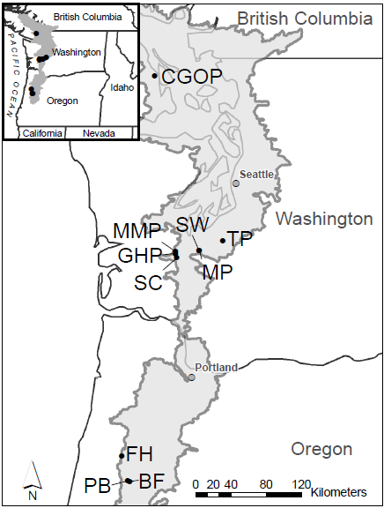

Figure 1 IAE/TNC research sites, ours are the southernmost sites, Pigeon Butte (PB), Bellfountain (BF) and Ft. Hoskins (FH)

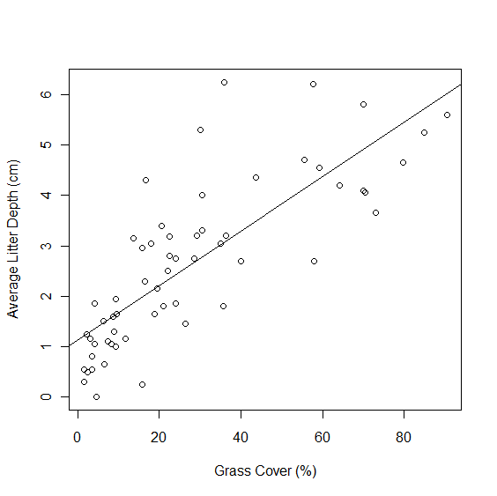

Figure 2 Litter depth compared with grass cover (p<0.0001, R2=0.33).

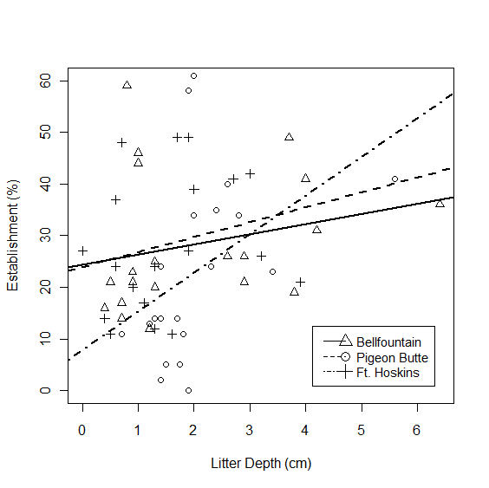

Figure 3. Establishment of *L. oreganus* relative to average litter depth at three sites (p=0.03, R2=0.11).

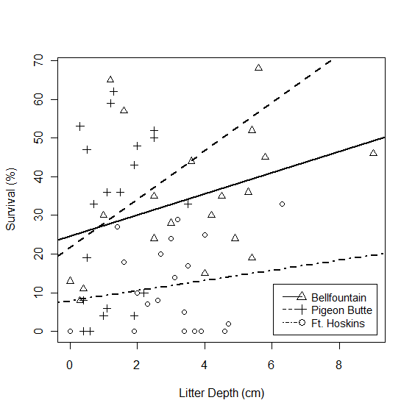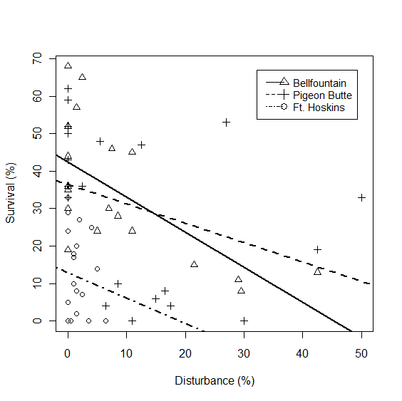

A)

B)

Figure 4. Survival of *L. oreganus* seeds compared to (left) litter depth (p= 0.05) and (right) soil disturbance from moles (p=0.0005).

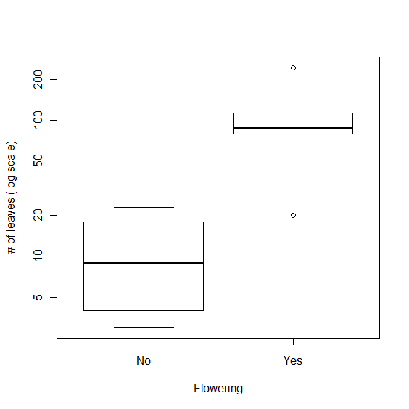

Figure 5 Boxplot of number of *L. oreganus* leaves (log scale) in plots with and without lupine flowers

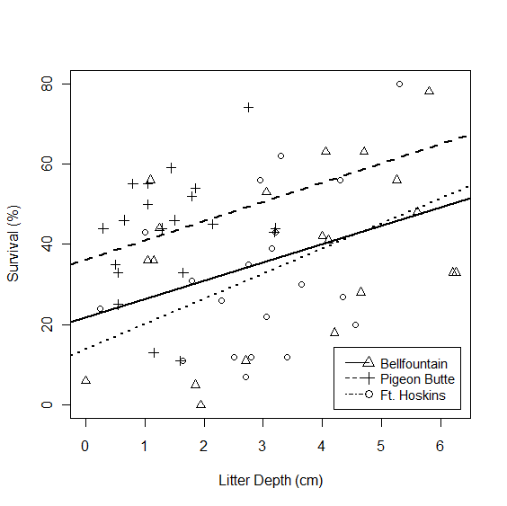

Figure 6 Survival of *S. malviflora* compared to litter depth at three study sites (p=0.004).

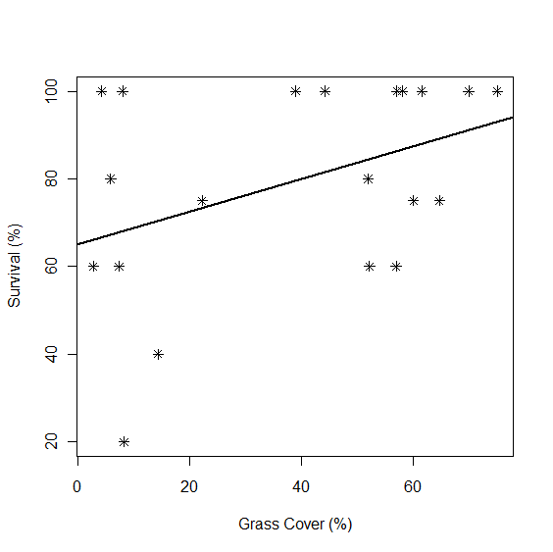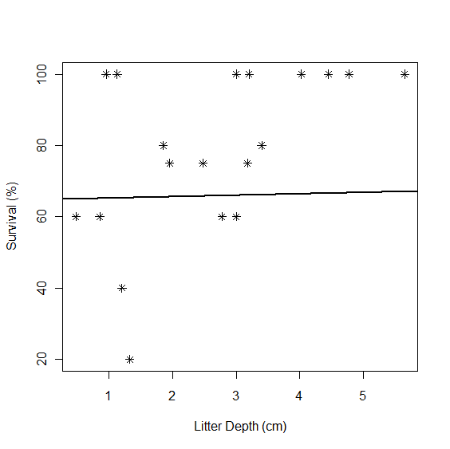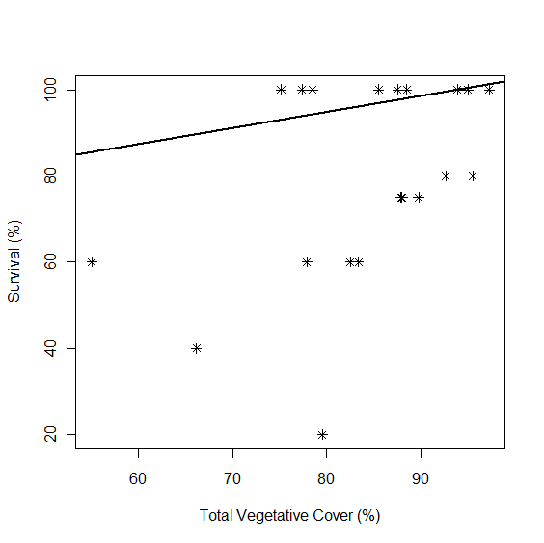

Figure 7. Survival of planted *Castilleja levisecta* as a function of cover of, from left to right, grass (p=0.07), total cover of vascular plants (p=0.04) and, litter depth (p=0.01).

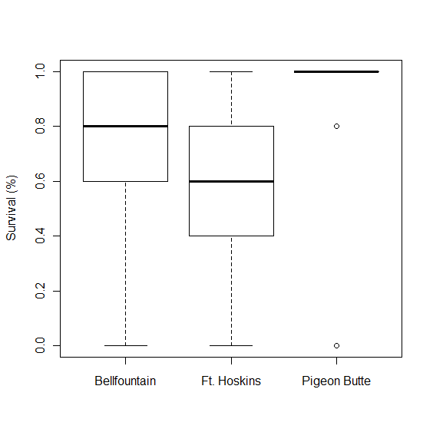

Figure 8 Boxplot of *Iris tenax* survival by site (p=0.019)

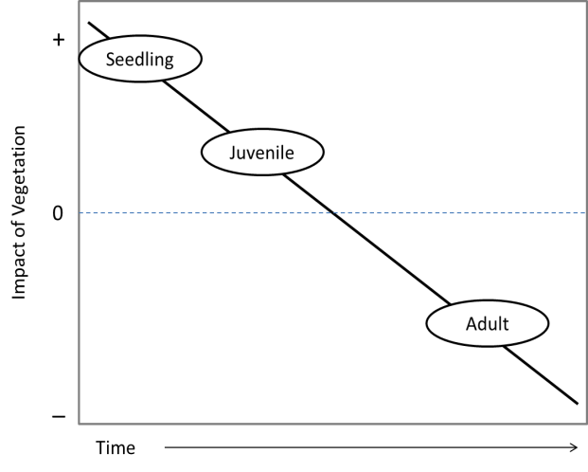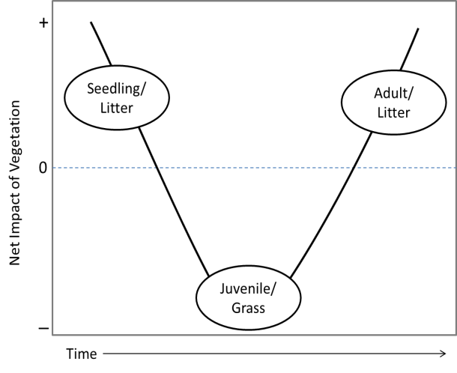

B)

A)

Figure 9. Two conceptual models of the shift between facilitative to competitive interactions with existing community over successive life history stages of an individual A) The net or driving interaction may differs by functional group for different life history stages. B) The interaction with a single functional groups shifts in one direction with successive life history stages.